Cardiovascular Disease
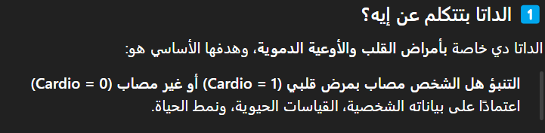

Total Columns 13
Total Rows 70,000
Type of data Classification

📌 مصدر:
WHO – Cardiovascular diseases
منظمة الصحه العالميه
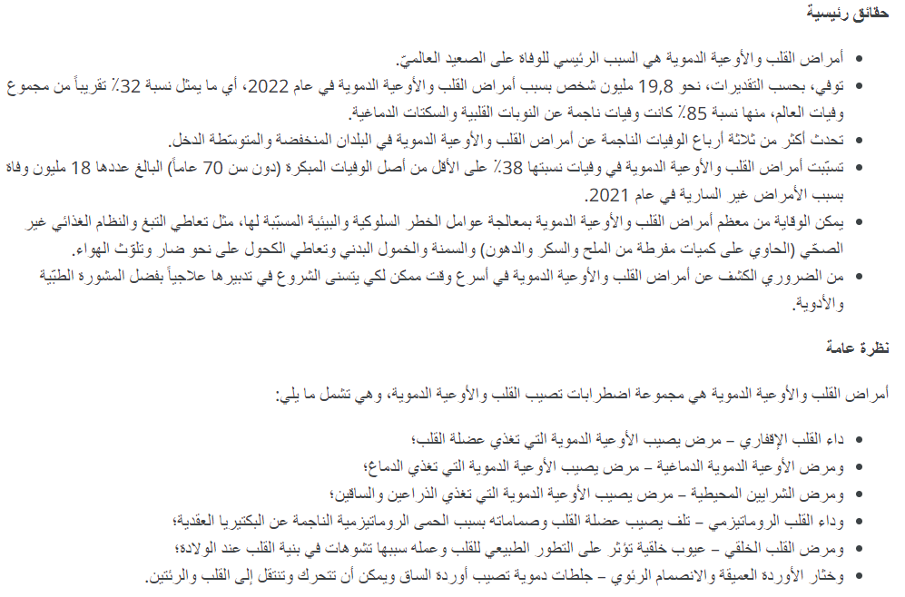



Feature

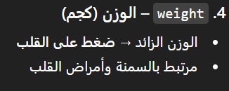
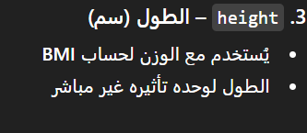

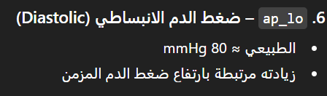









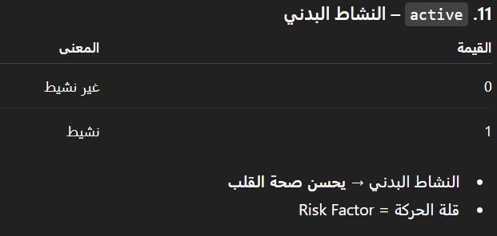

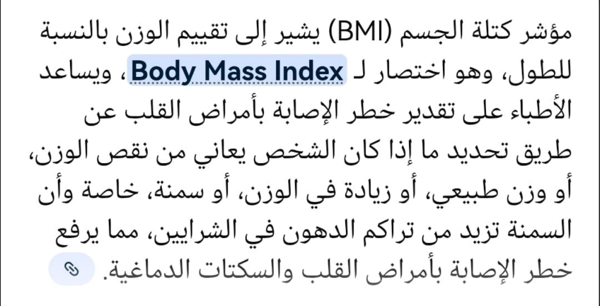

____________________________________________________________________________________
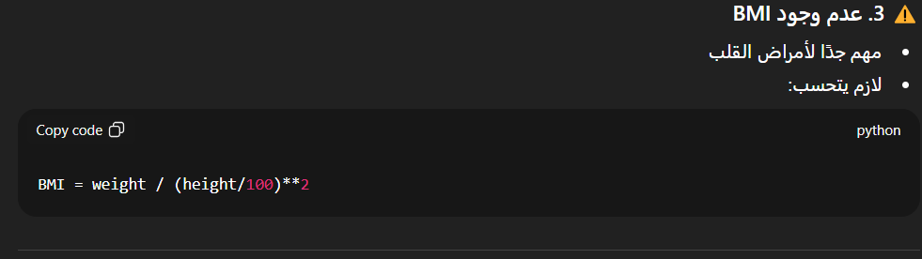

(Data Issues)

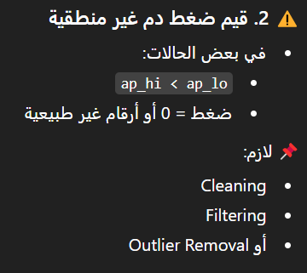

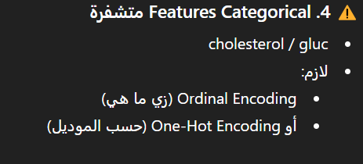

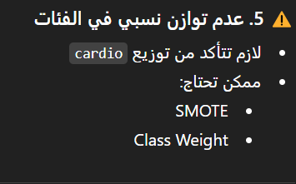

Pipeline

📌 Data Processing Steps
- Loaded cardiovascular dataset (cardio_processed.csv)
- Removed irrelevant features (ID)
- Calculated BMI and categorized into BMI_Class
BMI = weight / (height/100)^2
- Calculated Mean Arterial Pressure (MAP) and categorized into MAP_Class
MAP = (ap_hi + 2 * ap_lo) / 3
- Converted age into categorical bins (age_bin)
- Encoded categorical medical variables (cholesterol, glucose, lifestyle)
- Applied K-Means clustering to segment patients into health groups
- Produced final dataset (cardio_clusters_final.csv) for ML prediction

Feature engineering and discretization were applied to transform continuous medical variables into categorical risk levels, improving model interpretability and performance.


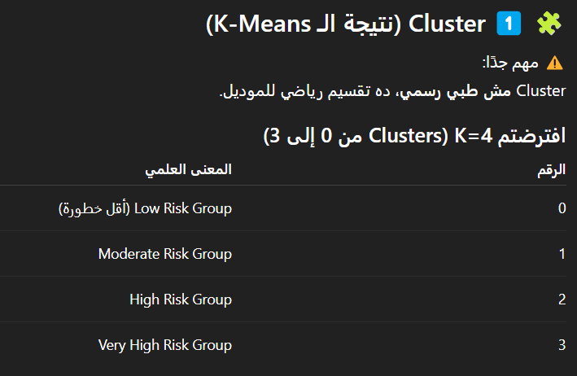
final dataset

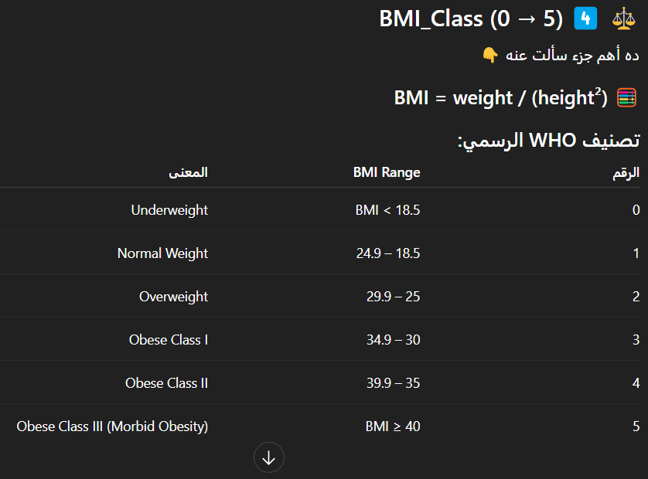
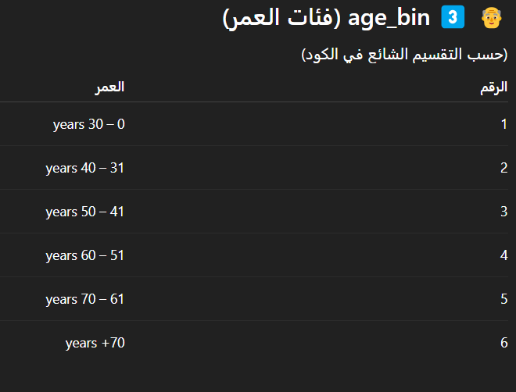

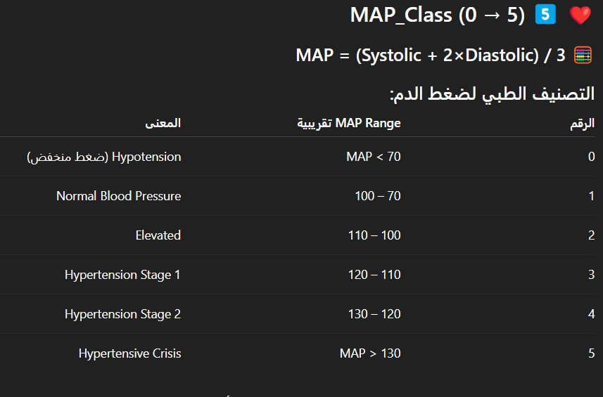

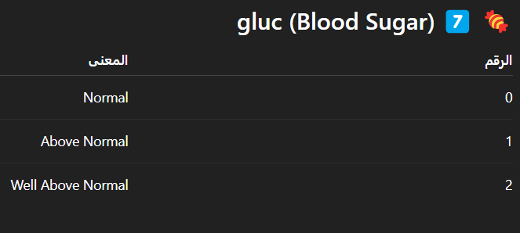
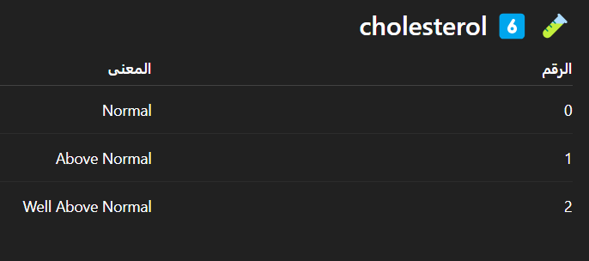

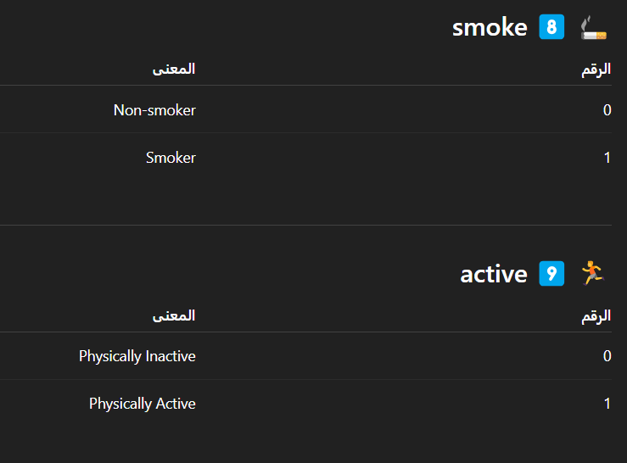

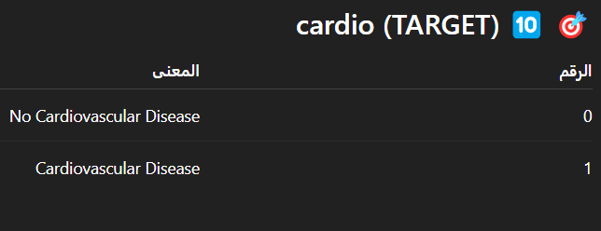


Why use Clustering
K-Means clustering was applied to segment patients into homogeneous health groups, and the resulting cluster label was used as an additional feature to enhance supervised cardiovascular disease prediction.




